Civil war in Liberia

UNSC Resolution: | 985
Date of adoption: | 13-Apr-1995
Operative paragraph: | 3
Demand number: | 985,0311

Sarah-Myriam Martin-Brûlé

Wording of demand

promote implementation of the Akosombo and Accra Agremeents, and continue to do all in their power to facilitate a political settlement in Liberia

List of addressees of the demand

Government of Liberia

Short-term compliance

Description of the addressee(s)’ conduct

On 10 June 1995, pursuant to resolution 985 (1995), the Secretary-General submitted to the Council his eleventh progress report on UNOMIL. The Secretary- General indicated that fighting between the factions had continued, and they had continued to block access routes into inhabited areas, resulting in the disruption of the delivery of relief supplies and the unnecessary suffering of civilians. Several towns had changed hands and there had been reports of human rights abuses as combatants moved into or out of a particular area.

http://www.un.org/fr/sc/repertoire/93-95/CHAPTER%208/AFRICA/item%2005-%20Liberia.pdf

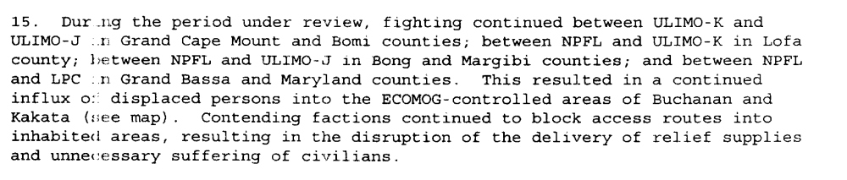

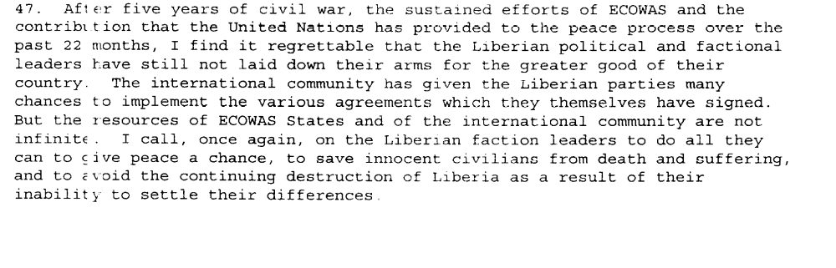
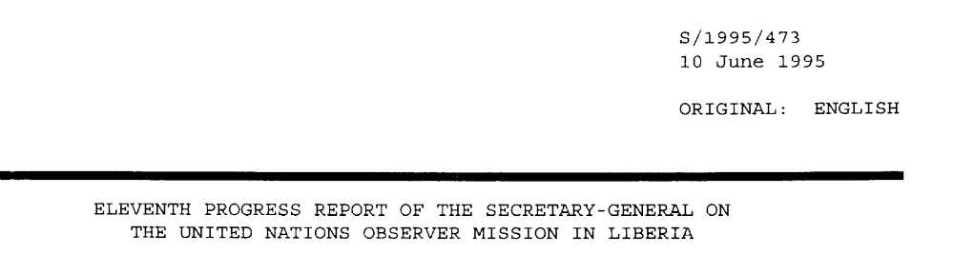

The Akosombo Agreement was initially signed by the signatories to Cotonou. The amendments contained in this agreement focused more on including the Liberian National Transitional Government (LNTG) in the peace process

The Acceptance and Accession Agreement signed in Accra was intended to include other warring factions
who were not signatories to Akosombo. The Abuja Agreement was largely a reaffirmation of Akosombo and Cotonou.

“From 19 to 22 July, ECOWAS foreign ministers held a consultateive meeting with Liberian parties in Monrovia. At this meeting, Liberia’s interim President, David Kpomakpor, called for a revision of the Accra agreement and a possible return to the 1993 Cotonou agreement which had excluded the warlords from direct participation in the Council of State. The NPFL walked out after unsuccessfully trying to limit the size of the Coalition’s delegation. (…)Members of the meeting agreed that the chairman of the Council of State should have voting power and cast the deciding vote in the event of a tie. It called for suspension from the LNTG of any party against which ECOMOG was to take enforcement action for violating the Accra agreement. Neither the NPFL nor ULIMO-J signed the final agreement “ (Adebajo 2002: 167)

“During the meeting with ECOWAS heads of state on 18-19 August (…). The powerful warlords Taylor, Kromah and Boley were nominated to be vice chairmen and asked to suggest names for chairman. (…) The spirit of Abuja was vividly captured by Charles Taylor’s extension of a hand of reconciliation to his two NPFL defectors, Tom Woewiyu and Laveli Supuwood. (…) Along with three powerful warlords, three civilians were nominated to the Council of State (…) The Abuja agreement was signed on 19 August 1995. It modified the Cotonou and Akosombo agreements and clarified the Accra agreements. A cease-fire would come into effect on 26 August 1995; ECOMOG and UNOMIL would deploy throughout the country between 2 October and 14 December 1995; combatants were to move to assembly points between 9 November and 1 December 1995 and 30 January 1996. (Adebajo 2002: 168)

Assessment

Short-term compliance
No or marginal compliance (1) | Medium low compliance (2) | X Medium high compliance (3) | Full or almost full compliance (4)

Considerations underlying the assessment

The demand addressee did not succeed in implementing the cease-fire included in the Akosombo and Accra Agreements. However, it successfully promoted the implementation of the Akosombo and Accra Agremeents with the signing of the Abuja accord. Hence, the demand addressee complied with those aspects of the demand which were of relatively high significance to the achievement of the objectives of the demand.

Medium-term compliance

Description of the addressee(s)’ conduct

“Despite all the concessions of the Abuja Agreement, a power struggle ensued soon after the signing of the agreement and the appointment of the six members of the Council of State over appointments for positions in government. Many of the government positions were allocated along factional and ethnic lines, serving the interests of the faction leaders (Sesay 1996b; Oquaye 2001). Fighting broke out on several fronts as groups tried to secure power over resources and territory or tried to eliminate opponents: ULIMO-J attacked ECOMOG in December 1995 over control of diamond mines and disarmament, resulting in the suspension of ECOMOG’s disarmament program.

Taylor’s decision to send his own forces to arrest Johnson was viewed as the start of a campaign to eliminate his opponents (ibid; Gberie 2005b; Bekoe 2003; Adibe 1997). This was supported by ECOMOG, from whom Johnson (likely in alliance with the NPFL) had stolen equipment (Bekoe 2003).

In the ensuing fighting in Monrovia, George Boley left the Council of State and joined forces with Johnson. The fighting facilitated by the fact that the factional militias had been allowed to enter the capital after the signing of the agreement
rather than disarming them outside the capital (creating a large security problem in the capital with increasing numbers of armed fighters entering Monrovia), and by the fact that ECOMOG and UNOMIL continued to be weak and under-funded (Sesay 1996b; Reno 2004; Alao 1996). Fighting then broke out within the NPFL, between the NPFL and ULIMO-K, and between ULIMO-J, LPC, and elements of the AFL over territorial control in April 1996. The
Abuja Agreement was effectively broken, leading to the signing of the Supplement to the Abuja Accord (known as Abuja II), which was signed on 17 August 1996.

Abuja II replaced the head of the Council of State with Ruth Perry, the country’s
first female head of state. The agreement contained threats regarding asset-freezing and the establishment of war crimes tribunals to try warlords who continued fighting, but also provided for disarmament and demobilization; the dissolution of all factional militia; and for elections in May 1997, which Charles Taylor won (Sesay, 1996b). Taylor dominated the Council of State, and used his position in government as a platform to campaign during the elections (Oquaye 2001; Sesay 1996b). The ECOMOG-enforced peace in Liberia meant that Taylor’s opponents could not re-arm and Taylor’s position in government allowed Taylor to intimidate, disarm and eliminate his enemies and civilian critics in the name of keeping the peace as he continued down the political path and prepared for the elections. The external guarantors of the 1995 agreement failed to constrain Taylor in his actions, since they realized that peace could not be won without him (Reno 2004).
Though the Abuja II Agreement was the last agreement signed of the first period of Liberia’s civil war, and ended in successful elections, these elections also brought the country’s strongest warlord to power. This would prove detrimental to the stability of the country, as Taylor’s presidency spawned the birth of two new ULIMO-based rebel groups who reignited the conflict to rid the country of Taylor. (Dupuy & Detzel, 1997 p.14-15)

“The Abuja Agreement was largely a reaffirmation of Akosombo and Cotonou. However, the renewed hostilities in Liberia in April 1996 appear to have created a major setback for the peace process.”

Olonisakin, Funmi(1996)'UN co-operation with regional organizations in peacekeeping: The experience of ECOMOG and UNOMIL in Liberia',International Peacekeeping,3:3,33 — 51
http://pdfserve.informaworld.com/956505_751319779_784175576.pdf

Assessment

Medium-term compliance
No or marginal compliance (1) | Medium low compliance (2) | Medium high compliance (3) | Full or almost full compliance (4)

Considerations underlying the assessment

The signing of the Abuja Agreement, which was mostly a reaffirmation of Akosombo and Cotonou agreements translates in the demand addressees adhesion to the Akosombo Agreement (S/1994/1174) and the Accra Agreement (S/1995/7). The Council of States was established five months after the resolution was adopted. Yet the parties failed to re-establishing an effective cease-fire and to implementation other provisions of the Agremeents

Depth of demand

Assessment

Level of depth of demand
Low depth of demand (1) | Medium depth of demand (2) | High depth of demand (3)

Considerations underlying the assessment

The signing of the Abuja Agreement, which was mostly a reaffirmation of Akosombo and Cotonou agreements translates in the demand addressees’ adhesion to the Akosombo Agreement (S/1994/1174) and the Accra Agreement (S/1995/7).

“The logic of Abuja accord was to give to the armed factions joint control of the government of Liberia, encouraging them to pursue by political means the interest which they had previously contested in battle. This soon led to antagonism (…) it also offered all the factions a chance to occupy government positions. (…) The various factions could now combine control of the resources of the hinterland with opportunities offered by access to the facilities of a sovereign state. (Ellis 1999: 107).”

Level of confidence about coding decisions

Level of confidence about coding decision
Extremely high | X High | Moderate

Comments to IPI (if any)

